LIMIT REFERENCE POINTS AND WILD SALMON POLICY RAPID STATUS SUMMARY:

2023 INTERIOR FRASER COHO STOCK MANAGEMENT UNIT

Context
A key recommendation from a CSAS peer review process on Pacific Salmon Limit Reference Points (LRPs) is ‘CU [conservation-unit] status-based LRPs’ be used to meet the Fish Stocks provisions of the Fisheries Act (DFO 2022; Holt et al. 2023a, 2023b), which was supported nationally (DFO 2023). LRP's are assessed for Stock Management Units (SMUs), which can include one or more conservation units (CUs) (i.e., CUs are nested within SMUs). Using this approach, serious harm to a SMU is identified when any component CU zone drops into the Wild Salmon Policy (WSP) Red zone. Under this definition, the CU status-LRP is ‘100% of CUs with statuses above Red status’. The implications are that if a single CU is the Red status zone, the SMU is assessed as being below its LRP, which in turn triggers a DFO rebuilding plan for the SMU.

Forewords
Expert reviewers expressed concerns that the Wild Salmon Policy Rapid Status Algorithm does not account for changes in spawner distribution within CUs. Because the scanner only uses total CU spawner abundances and/or trends in abundances, it assumes that CUs with even versus uneven spawner distributions relative to the productivity of each component population are equally healthy. Declining evenness in spawner distribution within a CU may signal a productivity decline, but relatively large and productive populations can temporarily mask a decline when solely using total CU abundance to estimate status. Reviewers also expressed concerns that spawner escapements without information on sex ratios risks overestimating the productivity of a spawning run if the ratio is skewed towards males.

Data
The Interior Fraser Coho SMU contains five CUs (Fraser Canyon, Lower Thompson, South Thompson, North Thompson, and Middle Fraser). These five CUs comprise of a total of 97 systems, 76 of which are included in this assessment (Table 1). The data used in this assessment were described in detail by Arbeider et al. (2020). The last integrated status assessment for the CUs in this SMU occurred for return year 2013 (DFO, 2015a). Some of the data were also recently used in the Interior Fraser Coho Recovery Potential Assessment (Arbeider et al., 2020) and the Interior Fraser Coho Fisheries Science Response Report (DFO 2025).
The primary forms of spawner enumeration surveys vary across the CUs within this SMU. There is also variation in enumeration methods throughout the time series for some CUs within this SMU. Fraser Canyon data were collected by a combination of visual survey methods; including standardized Area-under-the-curve (AUC) or applying a peak count expansion factor. Visual survey coverage ranged from moderate effort (1-4 surveys) to high effort (> 5 surveys) from 1998-2023.
Lower Thompson data were collected using various high and low precision methods. Four systems in this CU were enumerated using high precision methods from 1998-2023. Bonaparte River was assessed using fixed-site census from 1998-2003 and a resistivity counter from 2004-2023. Coldwater River was assessed by mark-recapture from 1998-2001, a resistivity counter from 2005-2011 and a combination of fence and SONAR counts from 2013-2023. Deadman river was assessed using fixed-site census from 1998-2003, and primarily using a resistivity counter from 2004-2023. Spius Creek was enumerated by fixed-site census from 1998-2006, and by SONAR from 2013-2023. Tranquille River was assessed using visual survey methods (AUC or peak count expansion), ranging from moderate to high effort between 2001-2023.
South Thompson data were collected using various high and low precision methods. Majority of the systems in this CU were enumerated using visual survey methods (AUC or peak count expansion), ranging from moderate to high effort between 1998-2023. Eleven systems in this CU were collected using a combination of low and high precision methods throughout the time series (1998-2023). Eagle River was assessed by mark-recapture consistently from 2001-2012. From 2013 onwards, Eagle River was assessed using a combination of fence counts, SONAR and visual surveys below the fence. Similarly, Salmon River was consistently assessed solely using fence counts from 1998-2000. From 2001 onwards, visual surveys were added to obtain an AUC estimate downstream of the fence. Scotch creek was assessed using a fence for a single year in 2010, all other years between 1998-2023 were enumerated by visual surveys. Remaining tributaries in the Shuswap watershed (Tappen Creek, Canoe Creek, Bessette Creek, Duteau Creek, Danforth Creek) and Adams drainage (Hiuihill Creek, Momich river, Sinmax Creek) were enumerated by fence or mark recapture methods for a limited number of years earlier in the time series, but later were shifted to visual survey methods.
North Thompson data were collected using various high and low precision methods. Four systems in this CU were collected using high precision methods throughout the time series (1989-2023). Dunn creek was assessed using a mark-recapture from 1998-1999, and using a fixed site census from 2000-2023. Lemeuix Creek was assessed primarily by mark-recapture from 1995-2010 and a resistivity counter was installed for a single year in 2014. From 2015-2023, Lemeiux Creek was assessed using high effort visual surveys. Louis Creek was assessed by a fixed-site census from 1989-1992, by mark-recapture from 1995-2011 and by resistivity/SONAR from 2021-2023. There was a period (2012-2020) where only high effort visual surveys were conducted for Lemeiux. Mann Creek was assessed using mark-recapture from 1998-1999, and using moderate-high effort visual surveys from 2001-2023. The remaining systems were enumerated by visual surveys, ranging from low to high effort from 1998-2023.
Middle Fraser data were collected using various high and low precision methods. Two systems in this CU were enumerated using high precision methods from 1998-2023. Bridge River was assessed using a resistivity counter from 2013-2016 and SONAR from 2018-2023. Prior to 2013, Bridge River was assessed using visual survey methods (AUC and peak count expansion). Mckinley River was assessed using a combination of fence and SONAR counts, supplemented by visual surveys downstream of the fence location from 1998-2023. The remaining systems were enumerated by visual surveys, ranging from low to high effort between 1998-2023.
Key steps in the processing of this data set includes assessing data quality, which are described in detail in Pestal et al. (2023). Data quality is assessed based on the number and completeness of surveys, coverage of the spawning period, visibility and reliability records, and methodology.
The average spawner data quality is considered moderate, with high quality spawner data where sonar or resistivity counters have been implemented.
Relative Abundance Benchmarks:
Relative-abundance based benchmarks for the five CUs within this SMU were developed by fitting a Ricker stock-recruit model to each CU and calculating S_{gen} and S_{MSY} from the model parameters (Interior Fraser Coho FSRR. The 50th percentile benchmarks are presented for each CU (Table 2).
Table 1. Conservation Units (CUs) included in this Stock Management Unit (SMU) and lists of the streams/populations within each CU used in the Rapid Status Assessment. Streams have their NuSEDS population identifications in brackets.
CU No# | CU Name | Streams (Population ID) | Timeseries
CO-05 | Fraser Canyon | Nahatlatch River (47159) | 1998-2023
CO-07 | Lower Thompson | Bonaparte River (46200)  Coldwater River (46190)  Deadman River (46210)  Spius Creek (46180)  Tranquille River (44975) | 1984-2023
CO-08 | South Thompson |  | 1975-2023
  Adams River Upper (46250)
  Bessette Creek (46542)
  Canoe Creek (46421)
  Cayenne Creek (46280)
  Celista Creek (46320)
  Crazy Creek (806)
  Creighton Creek (46552)
  Danforth Creek (45601)
  Duteau Creek (46562)
  Eagle River (46360)
  Harbour Creek (3069)
  Harris Creek (46572)
  Hiuihill Creek (132)
  Hunakwa Creek (46340)
  McNomee Creek (45016)
  Momich River (46270)
  Nikwikwaia Creek (3071)
  Owlhead Creek (46370)
  Perry River (133)
  Salmon River (46401)
  Scotch Creek (46290)
  Senn Creek (3074)
  Shuswap River Lower (46431)
  Shuswap River Middle (46441)
  Sinmax Creek (46260)
  South Pass Creek (46380)
  Tappen Creek (46391)
  Wap Creek (46521)
  Wright Creek (3217)
  Yard Creek (7476)
CO-09 | North Thompson |  | 1975-2023
  Albreda River (46825)
  Avola Creek (46743)
  Barriere River Lower (46602)
  Barriere River Upper (46602)
  Birch Island Channel (46582)
  Blue River (46795)
  Cedar Creek (46805)
  Cook Creek (46815)
  Darlington Creek (53130)
  Dunn Creek (46652)
  East Barriere River (46612)
  Fennell Creek (46632)
  Finn Creek (46784)
  Haggard Creek (46622)
  Harper Creek (1170)
  Lemieux Creek (46642)
  Lindquist Creek (53131)
  Louis Creek (46592)
  Lyon Creek (46774)
  Mann Creek (46672)
  North Thompson River Middle (46582)
  North Thompson River Upper (46582)
  Paul Creek (53132)
  Peterson Creek (53133)
  Pig Channel (46582)
  Raft River (46712)
  Reg Christie Creek (46722)
  Shannon Creek (46753)
  Thunder River (127)
  Tumtum Creek (46764)
  Wire Cache Creek (46733)
CO-48 | Middle Fraser |  | 1984-2023
  Bridge River (47223)
  Chilko River (46845)
  Gates Creek (47213)
  Hazeltine Creek (Edney) (7780)
  Horsefly River (46895)
  Little Horsefly River (1505)
  McKinley Creek (45045)
  Mitchell River (46915)
  Penfold Creek (7008)
  Portage Creek (47183)
  Seton River Channels (44539)

Table 2. Relative abundance-based benchmarks by Conservation Unit (CU). The upper benchmarks are 85% S_{MSY} and the lower benchmarks are S_{gen}. Upper Benchmarks are multiplied by 1.1 in the algorithm.
CU Name | Benchmark | p50
Fraser Canyon | 80% S_{MSY} | 1,099
Fraser Canyon | S_{gen} | 327
Lower Thompson | 80% S_{MSY} | 3,170
Lower Thompson | S_{gen} | 2,359
South Thompson | 80% S_{MSY} | 3,529
South Thompson | S_{gen} | 2,599
North Thompson | 80% S_{MSY} | 4,975
North Thompson | S_{gen} | 2,692
Middle Fraser | 80% S_{MSY} | 2,380
Middle Fraser | S_{gen} | 1,676

WSP Rapid Status Summary
Stock Management Unit (SMU) Limit Reference Point (LRP) status and narrative based on expert consensus
There are five CUs in the Interior Fraser Coho SMU and they are designated as 3 Green and 2 Amber, placing this SMU above the LRP in terms of WSP rapid status (Figures 1-10 & Table 3).

Fraser Canyon (CO-05)
During the expert review meeting, habitat concerns were raised for this CU regarding slide activity. Float surveys have resumed since the 2021 floods. The 2022 season was significantly impacted by a large forest fire. In the summer of 2023, there was a significant rain event that caused high debris flow into the main channel, the DFO habitat restoration group assessed the area and determined that the debris flow did not impact fish passage.

Lower Thompson (CO-07)
During the expert review meeting, it was mentioned that there is interest from Upper Nicola to expand surveys in the area. Currently, there are no enumeration surveys above the Nicola dam but juveniles have been observed rearing in the area.

South Thompson (CO-08)
During the expert review meeting, it was noted that the previous rapid status run showed more Green status years in the time series, however , these have all been adjusted to Amber status because it was determined that aerial counts were inflated due to whitefish presence. For this year’s rapid status run, these inflated values were removed and infilled, which changed the overall time series to Amber status. Resistivity counts from Okanagan Nation Alliance projects have not been calibrated yet, therefore AUC estimates are currently being used for the rapid status algorithm. It was also noted that once 2024 Bessette data are completed by ONA, there will be 8 years of paired AUC and resistivity data to compare estimates.

North Thompson (CO-09)
During the expert review meeting, the alternating status between Green and Amber throughout the time series for this CU was discussed. The need for continued visual counts to gather calibration data for the SONAR trial in the upper mainstem was highlighted to improve estimates. The intention is for the SONAR location to be placed above all Sockeye spawning and rearing areas, and a full program is planned for the 2025 field season.

Middle Fraser (CO-48)
During the expert review meeting, enumeration methods for McKinley were discussed. The McKinley population is assessed by a combination of SONAR operation and fence with a trap, and increased population abundances may benefit from more passage opportunities associated with longer SONAR operation. A dead pitch survey is also conducted downstream of the fence on this program and in the Horsefly River.
There were also concerns assigning the CU status as Green due to habitat impacts from the Chilcotin River landslide in the Lower Chilcotin and marine harvest rates. It was noted that migration timing and abundance of the Chilko population were not significantly different post-slide compared to the historical data, however, these estimates are generated from lower precision aerial surveys.
Future work: Future work includes trialing mainstem SONAR in the North Thompson, expanding walking surveys to above Nicola Dam if possible, and calibrating the Bessette Creek coho counts with the resistivity counts the ONA have been producing.
Table 3. Wild Salmon Policy (WSP) Rapid Statuses for 2023. For background, refer to Appendix 1.
CU # | CU Name | WSP Rapid Status (YYYY) | WSP Rapid Status Node and Pathway
CO-05 | Fraser Canyon | AMBER,  HIGH | The recent year’s status (2023) is designated Amber with High confidence based on the algorithm. The data could be assessed as Absolute Abundance. The recent generational average is 4,450 spawners, and is above the relative abundance lower benchmark (Node 22; Figure 2, Table 4). This Amber status has been consistent throughout the time series from 2018 to 2023 and matches the Integrated status in 2013 (Figure 1).
CO-07 | Lower Thompson | GREEN,  HIGH | The recent year’s status (2023) is designated Green with high confidence based on the algorithm. The data could be assessed as Absolute Abundance. The recent generational average is 14,613 spawners, and is above the relative abundance upper benchmark (Node 36; Figure 4, Table 5). This Green status has been consistent throughout the time series from 2020-2023 (Figure 3). The 2013 Integrated status was Amber-Green. (Figure 3).
CO-08 | South Thompson | AMBER,  HIGH | The recent year’s status (2023) is designated Amber with high confidence based on the algorithm. The data could be assessed as Absolute Abundance. The recent generational average is 9,800 spawners, and is above the relative abundance lower benchmark (Node 22; Figure 6, Table 6). This Amber status has been consistent since the beginning of the time series in 2000; and matches the Integrated status in 2013. (Figure 5). However, note that in last year’s rapid status assessment, the South Thompson CU was assessed as Green. The reason the record has been amended to a consistent Amber status was due to an update in 2021 and 2022 escapement estimates for the Lower Shuswap River.
CO-09 | North Thompson | GREEN,  HIGH | The recent year’s status (2023) is designated Green with medium confidence based on the algorithm. The data could be assessed as Absolute Abundance. The recent generational average is 23,380 spawners, and is above the relative abundance upper benchmark (Node 36; Figure 8, Table 7). This Green status has been consistent throughout the status time series from 2018 to 2023 (Figure 7). The 2013 Integrated status was Amber-Green (Figure 7).
CO-48 | Middle Fraser | GREEN,  HIGH | The recent year’s status (2023) is designated Green with high confidence based on the algorithm. The data could be assessed as Absolute Abundance. The recent generational average is 13,902 spawners, and is above the relative abundance upper benchmark (Node 36; Figure 10, Table 8). This Green status is consistent with the 2022 rapid status assessment and does not match the Integrated Status of Amber in 2013 . (Figure 9).

Fraser Canyon (CO-05)
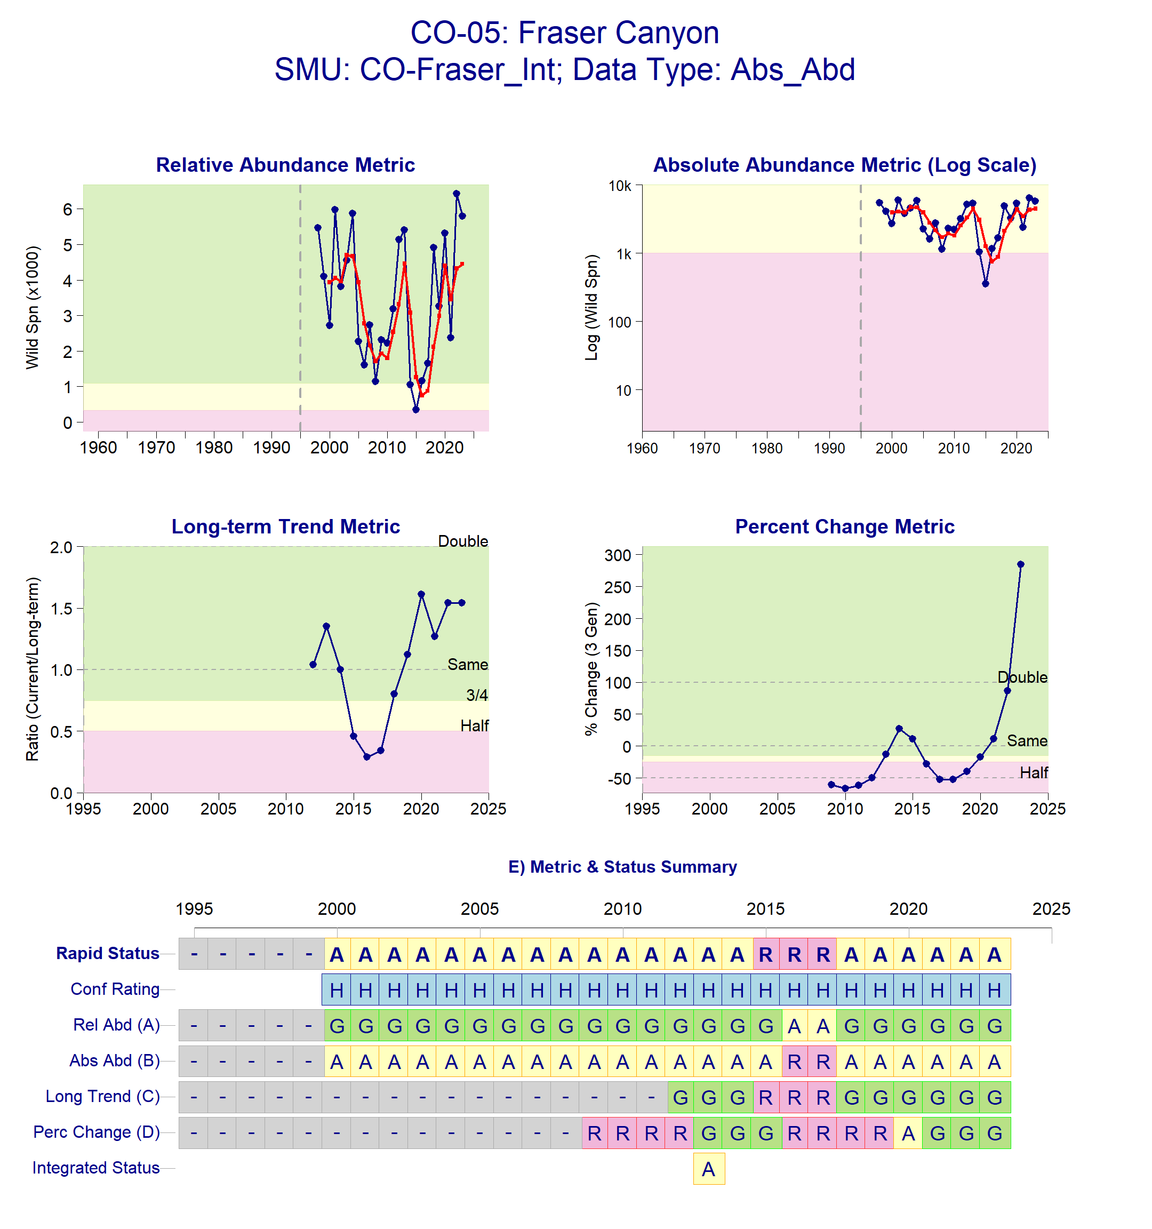

Figure 1: Metrics and Status for Fraser Canyon (CO-05). Panels on top show the four standard WSP metrics, calculated based on the available time series of spawner abundances. Bottom panel summarizes the status for each individual metric and shows the resulting WSP rapid status for the CU with a confidence rating. If integrated WSP status assessments have been completed for this CU, they are shown on the last row (IntStatus). Note that metric benchmarks may differ from algorithm thresholds, since thresholds approximate the status determination process from past WSP integrated status assessments (see Figure 2 and Table 4).
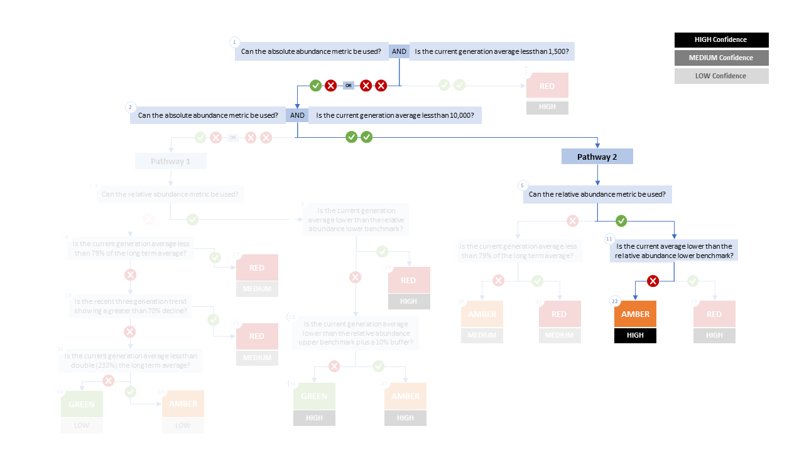

Figure 2. Algorithm pathway taken to assess status for Fraser Canyon in 2023 The recent generational average falls above the absolute abundance lower (1,500) threshold (node 1) but below the absolute abundance upper (10,000) threshold (node 2). Following algorithm Pathway 2, we do have a relative abundance metric for this CU (node 5) and the recent generational average falls above the lower benchmark (Sgen) (node 11). Status for this CU is therefore designated as Amber with High confidence at node 22 (see (DFO 2024) for definition of each node).
Table 4: Decision tree path given data and metric values for Fraser Canyon in 2023; this aligns with Figure 2 above. For each node, the algorithm decision is made by comparing the CUs current metric value to the metric threshold and answering Yes or No, running through sequential nodes and decisions until the final WSP rapid status for that CU and year is reached.
Node | Metric | Metric Threshold | CUs Current Value | Decision
1 | Absolute Abundance | <1,500 | 4,450 | NO, NO
2 | Absolute Abundance | < 10 000 | 4,450 | YES, YES
5 | Relative Abundance | Available? |  | YES
11 | Relative Abundance | < 327 | 4,450 | NO
22 | FINAL STATUS NODE |  |  | AMBER, HIGH

Lower Thompson (CO-07)
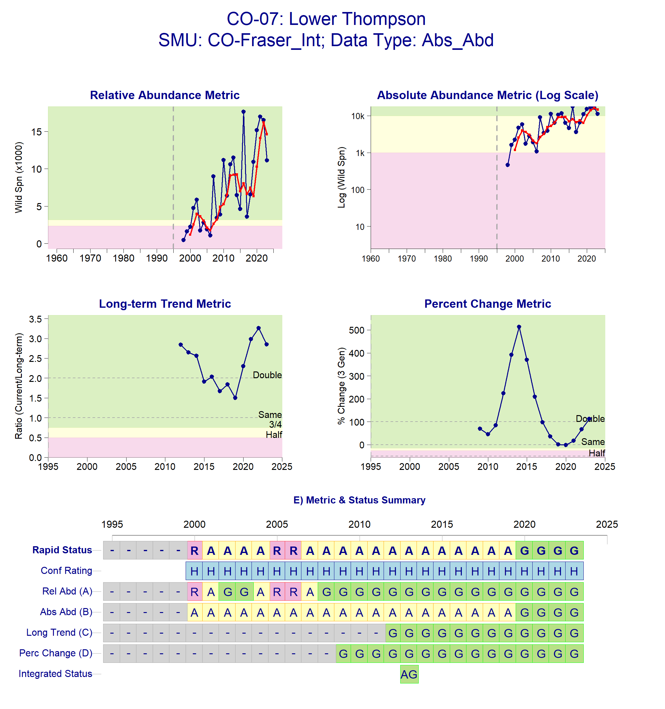
Figure 3: Metrics and Status for Lower Thompson (CO-07). Panels on top show the four standard WSP metrics, calculated based on the available time series of spawner abundances. Bottom panel summarizes the status for each individual metric and shows the resulting WSP rapid status for the CU with a confidence rating. If integrated WSP status assessments have been completed for this CU, they are shown on the last row (IntStatus). Note that metric benchmarks may differ from algorithm thresholds, since thresholds approximate the status determination process from past WSP integrated status assessments (see Figure 4 and Table 5).
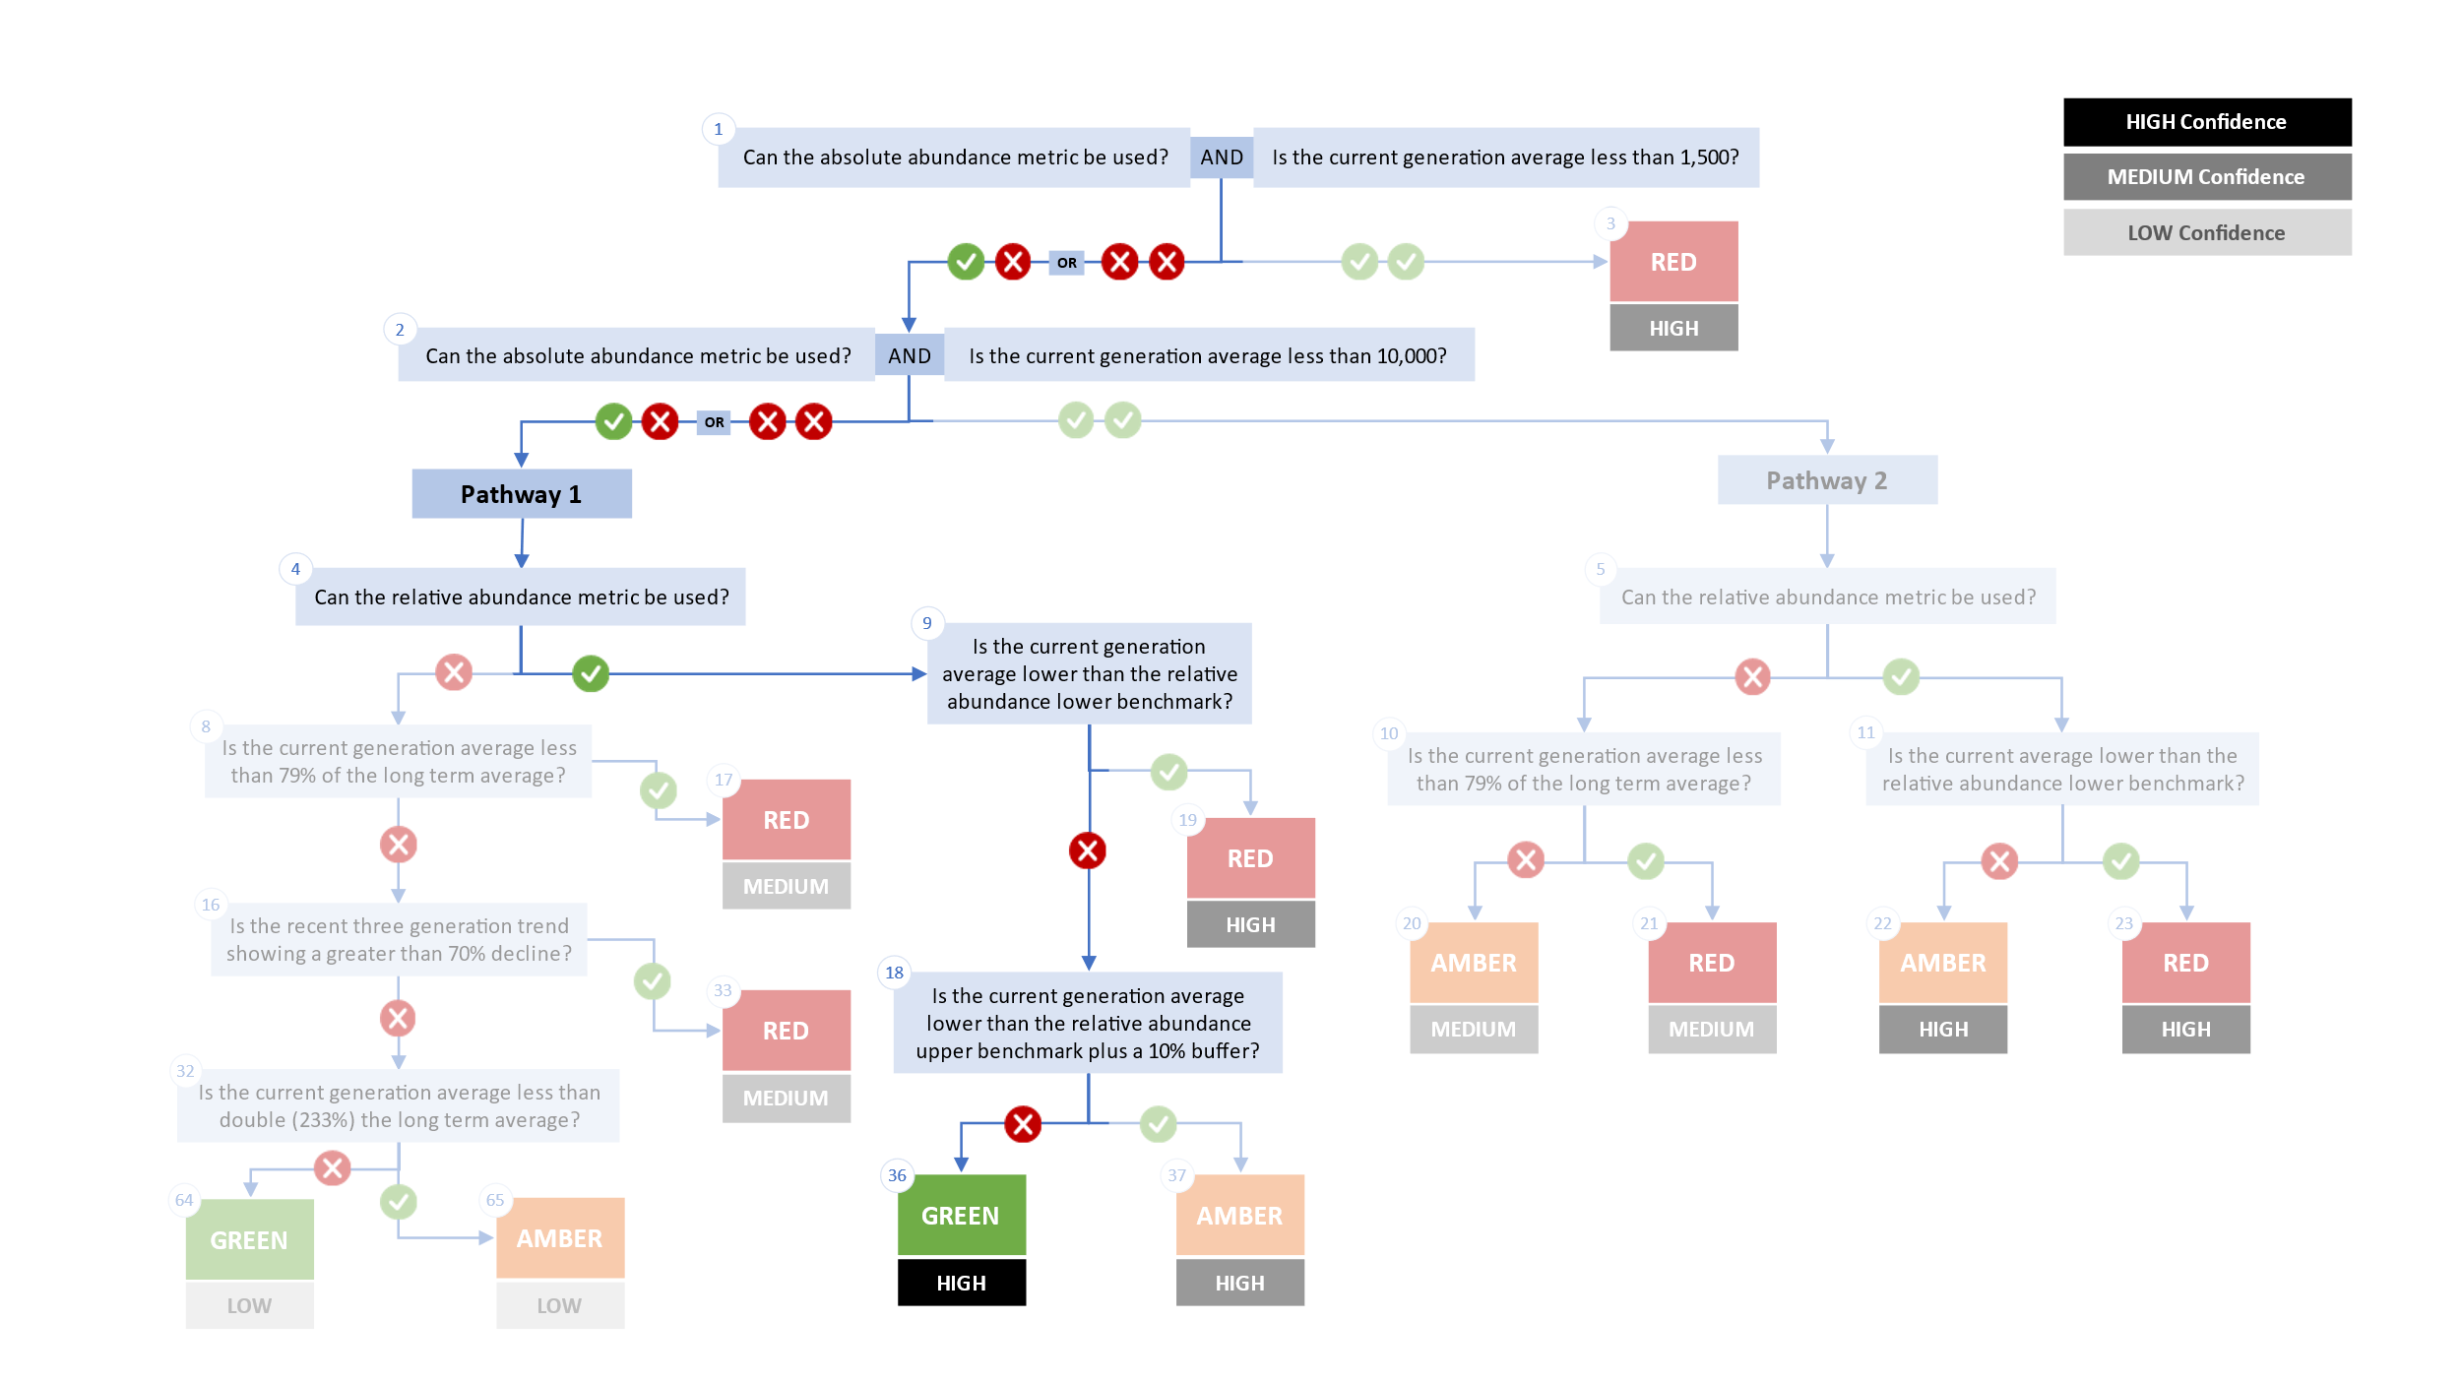
Figure 4. Algorithm pathway taken to assess status for Lower Thompson in 2023. The recent generational average falls above the relative abundance upper benchmark plus a 10% buffer (node 18). Status for this CU is therefore designated as Green with High confidence at Node 36.
Table 5: Decision tree path given data and metric values for Lower Thompson in 2023; this aligns with Figure 4 above. For each node, the algorithm decision is made by comparing the CUs current metric value to the metric threshold and answering Yes or No, running through sequential nodes and decisions until the final WSP rapid status for that CU and year is reached.
Node | Metric | Metric Threshold | CUs Current Value | Decision
1 | Absolute Abundance | <1,500 | 14,613 | NO, NO
2 | Absolute Abundance | <10,000 | 14,613 | NO, NO
4 | Relative Abundance | Available? |  | YES
9 | Relative Abundance | < 2,359 | 14,613 | NO
18 | Relative Abundance | < 3,487 | 14,613 | NO
36 | FINAL STATUS NODE |  |  | GREEN, HIGH

South Thompson (CO-08)
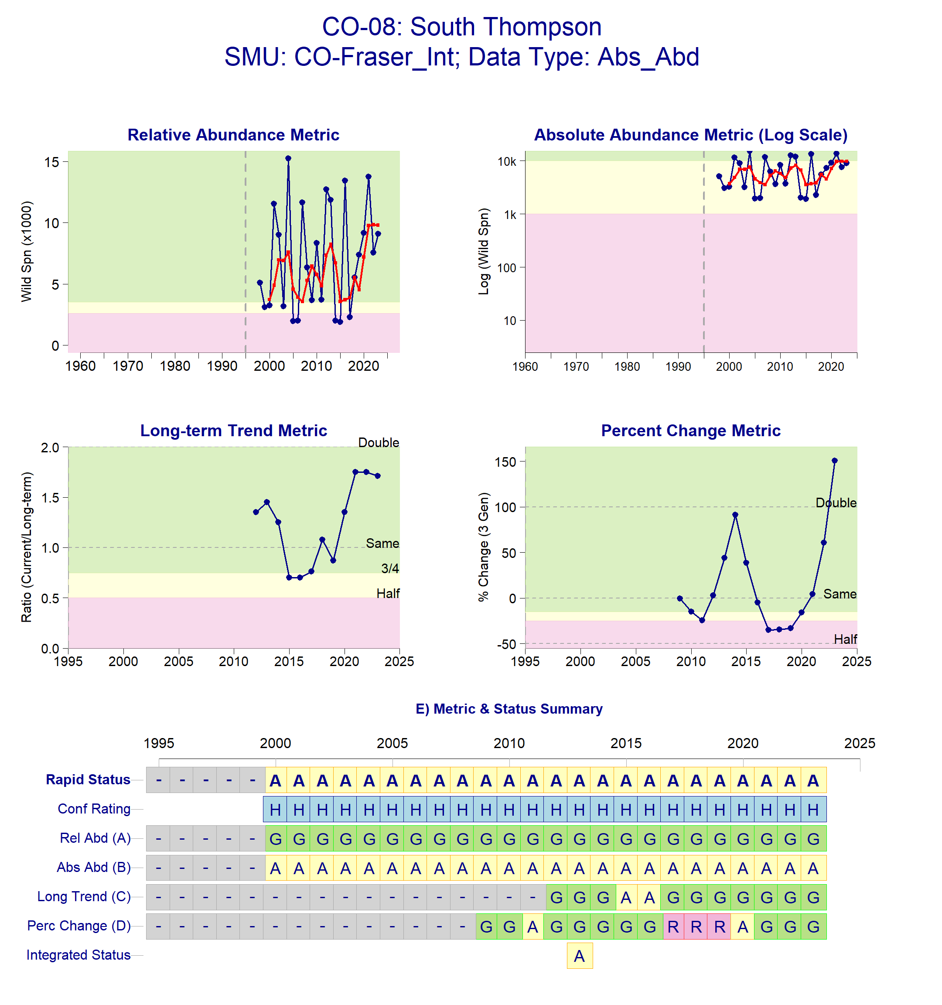
Figure 5: Metrics and Status for South Thompson (CO-08). Panels on top show the four standard WSP metrics, calculated based on the available time series of spawner abundances. Bottom panel summarizes the status for each individual metric and shows the resulting WSP rapid status for the CU with a confidence rating. If integrated WSP status assessments have been completed for this CU, they are shown on the last row (IntStatus). Note that metric benchmarks may differ from algorithm thresholds, since thresholds approximate the status determination process from past WSP integrated status assessments (see Figure 6 and Table 6).
Figure 6. Algorithm pathway taken to estimate status for South Thompson in 2023 The recent generational average falls above the absolute abundance lower (1,500) threshold (node 1) but below the absolute abundance upper (10,000) threshold (node 2). Following algorithm Pathway 2, we do have a relative abundance metric for this CU (node 5) and the recent generational average falls above the lower benchmark (S_{gen}) (node 11). Status for this CU is therefore designated as Amber with High confidence at node 22 (see (DFO 2024) for definition of each node).
Table 6: Decision tree path given data and metric values for South Thompson in 2023; this aligns with Figure 6 above. For each node, the algorithm decision is made by comparing the CUs current metric value to the metric threshold and answering Yes or No, running through sequential nodes and decisions until the final WSP rapid status for that CU and year is reached.
Node | Metric | Metric Threshold | CUs Current Value | Decision
1 | Absolute Abundance | <1,500 | 9,800 | NO, NO
2 | Absolute Abundance | < 10 000 | 9,800 | YES, YES
5 | Relative Abundance | Available? |  | YES
11 | Relative Abundance | < 2,599 | 9,800 | NO
22 | FINAL STATUS NODE |  |  | AMBER,HIGH

North Thompson (CO-09)
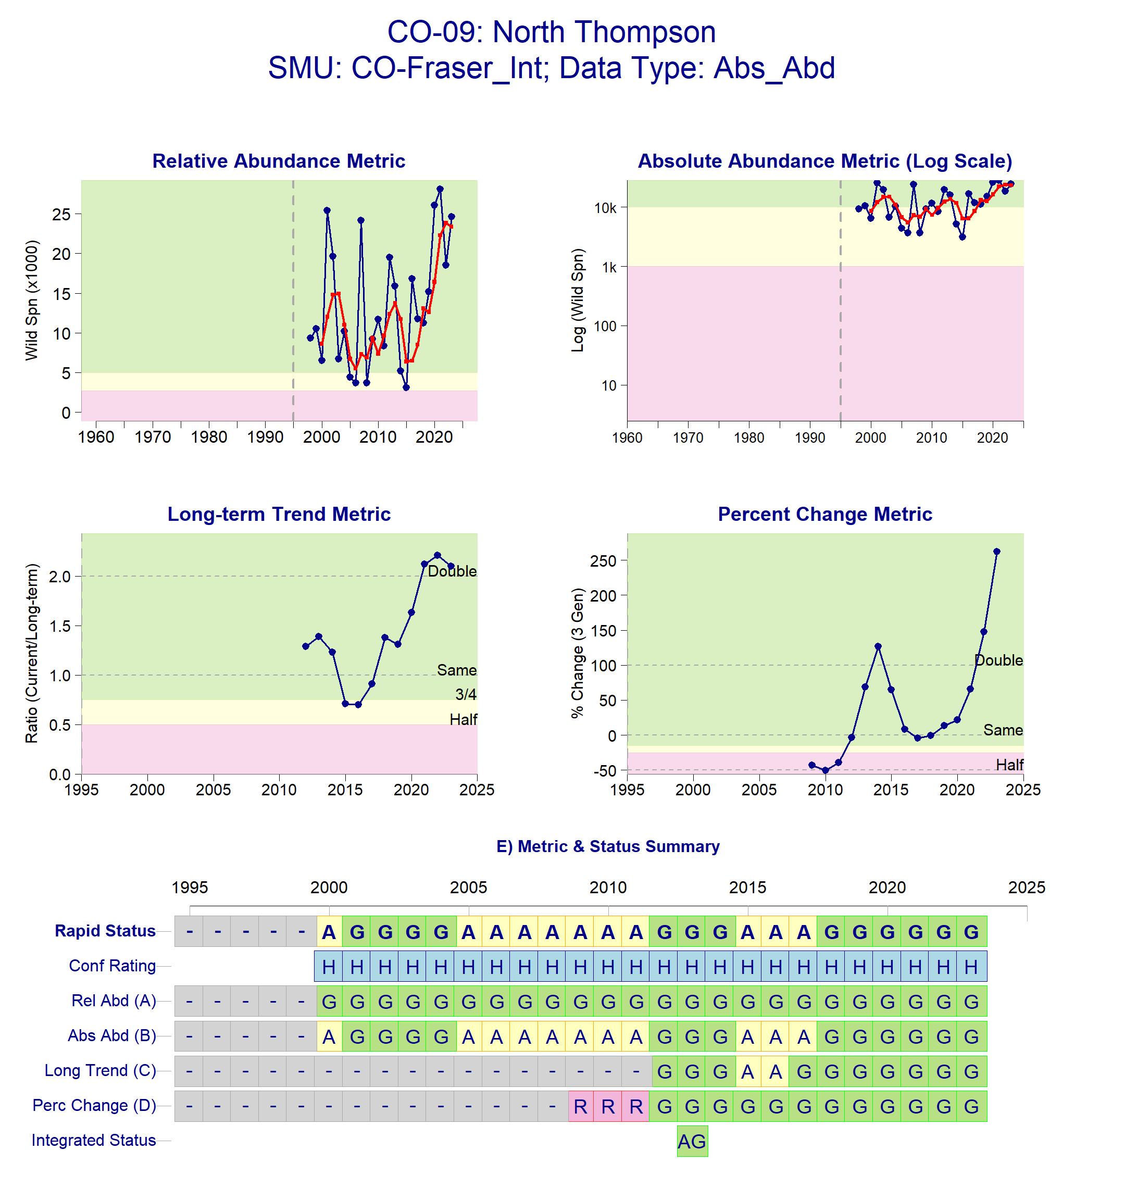
Figure 7: Metrics and Status for North Thompson (CO-09). Panels on top show the four standard WSP metrics, calculated based on the available time series of spawner abundances. Bottom panel summarizes the status for each individual metric and shows the resulting WSP rapid status for the CU with a confidence rating. If integrated WSP status assessments have been completed for this CU, they are shown on the last row (IntStatus). Note that metric benchmarks may differ from algorithm thresholds, since thresholds approximate the status determination process from past WSP integrated status assessments (see Figure 8 and Table 7).
Figure 8: Metrics and Status for North Thompson in 2023. The recent generational average falls above the relative abundance upper benchmark plus a 10% buffer (node 18). Status for this CU is therefore designated as Green with High confidence at Node 36
Table 7: Decision tree path given data and metric values for North Thompson in 2023; this aligns with Figure 8 above. For each node, the algorithm decision is made by comparing the CUs current metric value to the metric threshold and answering Yes or No, running through sequential nodes and decisions until the final WSP rapid status for that CU and year is reached.
Node | Metric | Metric Threshold | CUs Current Value | Decision
1 | Absolute Abundance | <1,500 | 23,380 | NO, NO
2 | Absolute Abundance | <10,000 | 23,380 | NO, NO
4 | Relative Abundance | Available? |  | YES
9 | Relative Abundance | <2,692 | 23,380 | NO
18 | Relative Abundance | < 5,292 | 23,380 | NO
36 | FINAL STATUS NODE |  |  | GREEN, HIGH

Middle Fraser (CO-48)
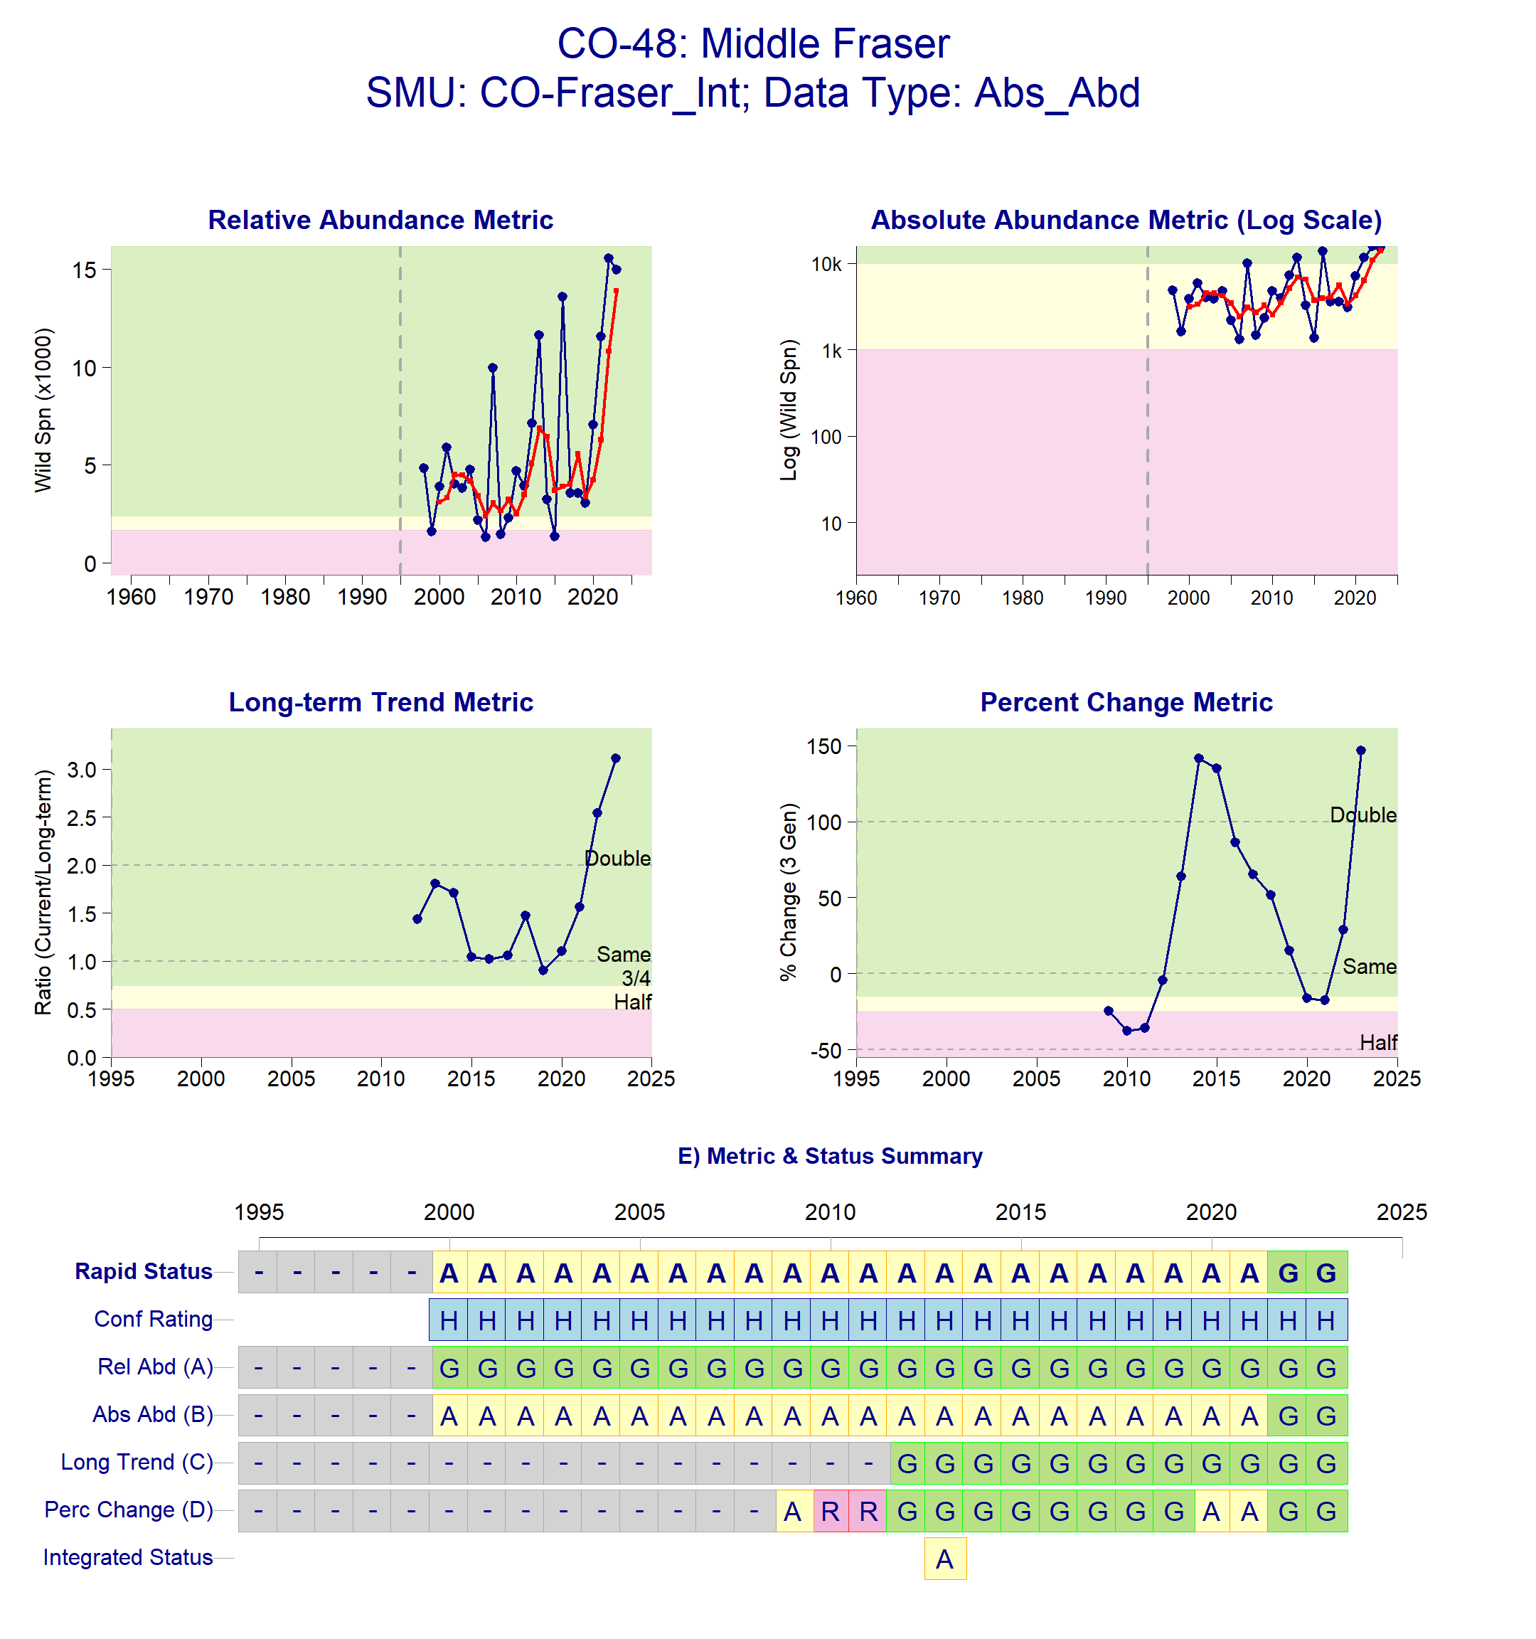
Figure 9. Metrics and Status for Middle Fraser (CO-48). Panels on top show the four standard WSP metrics, calculated based on the available time series of spawner abundances. Bottom panel summarizes the status for each individual metric and shows the resulting WSP rapid status for the CU with a confidence rating. If integrated WSP status assessments have been completed for this CU, they are shown on the last row (IntStatus). Note that metric benchmarks may differ from algorithm thresholds, since thresholds approximate the status determination process from past WSP integrated status assessments (see Figure 10 and Table 8).
Figure 10. Algorithm pathway taken to estimate status for Middle Fraser in 2023 The recent generational average falls above the relative abundance upper benchmark plus a 10% buffer (node 18). Status for this CU is therefore designated as Green with High confidence at Node 36
Table 8: Decision tree path given data and metric values for Middle Fraser in 2023; this aligns with Figure 10 above. For each node, the algorithm decision is made by comparing the CUs current metric value to the metric threshold and answering Yes or No, running through sequential nodes and decisions until the final WSP rapid status for that CU and year is reached.
Node | Metric | Metric Threshold | CUs Current Value | Decision
1 | Absolute Abundance | <1,500 | 13,902 | NO, NO
2 | Absolute Abundance | <10,000 | 13,902 | NO, NO
4 | Relative Abundance | Available? |  | YES
9 | Relative Abundance | < 1,676 | 13,902 | NO
18 | Relative Abundance | < 2,618 | 13,902 | NO
36 | FINAL STATUS NODE |  |  | GREEN, HIGH

Cited and other Key References
DFO. 2016. Integrated biological status of Southern British Columbia Chinook salmon (Oncorhynchus tshawytscha) under the Wild Salmon Policy.
DFO. 2022. Methodologies and guidelines for defining limit reference points for Pacific Salmon. CSAS SAR 2022/030. pp. 16.
DFO. 2023. Science advice on guidance for limit reference points under the fish stocks provisions. Canadian Science Advisory Secretariat Science Advisory Report 2023/009(February).
DFO. 2024. Rapid status approximations for Pacific salmon derived from integrated status assessments under DFO’s Wild Salmon Policy. Can. Sci. Advis. Sec. Sci. Resp. 2024/004: 1–42. Nanaimo, BC. Available from https://waves-vagues.dfo-mpo.gc.ca/library-bibliotheque/41207890.pdf [accessed 17 November 2024].
DFO. 2025. Interior Fraser Coho (Oncorhynchus kisutch) stock assessment for 2022. Canadian Science Advisory Secretariat (2025/nnn): 1–58.
Dionne, K., Parken, C., Weir, L., Doutaz, D., Bailey, R., Jenewein, B., Miller-saunders, K., Labelle, M., Welch, P., Trouton, N., Mozin, P., and Walsh, M. 2023. Recovery Potential Assessment for Southern British Columbian Chinook Populations , Fraser and Southern Mainland Chinook.
Holt, Carrie.A., Holt, K., Wor, C., Warkentin, L., Connors, B., Grant, S.C.H., and Huang, A.-M. 2023a. Guidelines for Defining Limit Reference Points for Pacific Salmon Stock Management Units. Can. Sci. Adv. Sec. Res. Doc. 2023/009: iv + 66.
Holt, K., Holt, C.A., Warkentin, L., Wor, C., Davis, B., Arbeider, M., Bokvist, J., Crowley, S., Grant, S.C.H., Luedke, W., McHugh, D., Picco, C., and Will, P. Van. 2023b. Case Study Applications of LRP Estimation Methods to Pacific Salmon Stock Management Units. Can. Sci. Advis. Sec. Res. Doc. 2023/010: iv + 129.
Pestal, G., Macdonald, B.L., Grant, S.C.H., and Holt, C.A. 2023. State of The Salmon: Rapid status assessment approach for Pacific salmon under Canada’s Wild Salmon Policy. Can. Tech. Rep. Fish. Aquat. Sci. (3570): 1–200.

Appendix A: WSP rapid status approach details

The decision tree sequence is as follows (see Figure A1; Table A1, A2):
- The first question is whether or not a CU has a current absolute abundance value, and if so, whether or not this value falls below the lower threshold of 1,500 (which adds a buffer to Committee on the Status of Endangered Wildlife in Canada (COSEWIC) Criterion D1 for small population size of 1,000). If the answer to this question is Yes, then the CU is assigned Red (node 3), with High confidence.
- If the answer to the first question is No, then the second question is whether or not the CU has a current absolute abundance value, and if so, whether or not the current abundance is below the upper threshold of 10,000, which is COSEWIC's Criterion C upper benchmark. This second question splits the decision nodes into two Pathways: Pathway 1 (No to this question) and Pathway 2 (Yes to this question).
  - Pathway 1: is where a CU either does not have a current absolute abundance value, or has these data, and it falls above the upper threshold for this metric. This pathway is split with the question: can this CU be assessed with a relative abundance metric. If the answer is Yes, a Red (nodes 19), Amber (nodes 37) or Green (node 36) WSP rapid status is assigned, with High confidence, depending on where the current abundance value falls relative to this metric’s lower and upper thresholds. If the answer is NO, then comparisons are made between the CUs current abundances and percent change to thresholds for these metrics, which assign a Red with Medium confidence, or Green or Amber with Low confidence status.
  - Pathway 2: is where a CU has absolute abundance data, and these abundances fall between the lower and upper thresholds. In this pathway, absolute abundances restrict WSP rapid statuses to only Amber or Red. This pathway is split with the question: can this CU be assessed with a relative abundance metric. If the answer is Yes, an Amber (node 22) with Medium confidence, or Red (node 23) with High confidence, is assigned, depending on whether the CUs current abundance value falls above the relative abundance metric lower threshold or below. If the CU cannot be assessed with a relative abundance metric, then it is compared to the lower threshold of the Long-Term trend metric and assigned Amber (node 20) with Medium confidence if above, or Red (node 21) with Medium confidence if below.

Table A1. Biological status zones under the Wild Salmon Policy (WSP).

Status |  | Definition
 | Red | Poor status CU facing an imminent threat of extinction [revised definition, given alignment with COSEWIC Endangered statuses]
 | Amber | “While a CU in the Amber zone should be at low risk of loss, there will be a degree of lost production. Still, this situation may results when CUs share risk factors with other, more productive units”. Aligns with COSEWIC Threatened and Special Concern statuses.
 | Green | “identif[ies] whether harvest are greater than the level expected to provide on an average annual basis, the maximum annual catch for a CU, given existing conditions…there would not be a high probability of losing the CU”. Aligns with COSEWIC Not at Risk statuses.
 | DD | Data deficient. CUs have been designated as DD if there is no data available, or if the available data is insufficient for calculating status metrics (after quality control).

Table A2. WSP rapid status Learning Tree 3 status assignments by node (see Figure 1). This table presents the decisions in Learning Tree 3 that led to Red or Amber or Green status assignments; status outcomes depend on the pathway and decisions made. The final node that corresponds to the status assignment is presented below (see Figure 1).
Node | Status | Rule
Node3 | Red | Data Type is Absolute Abundance AND Absolute Abundance < 1,500
Node17 | Red | Data Type is Relative Index OR Absolute Abundance ≥ 1,500;  then Data Type is Relative Index OR Absolute Abundance ≥ 10,000;  then no Relative Abundance lower benchmark; then Long Term Trend < 79%
Node19 | Red | Data Type is Relative Index OR Absolute Abundance ≥ 1,500;  then Data Type is Relative Index OR Absolute Abundance ≥ 10,000  then have Relative Abundance lower benchmark;  then Relative Abundance < Relative Abundance lower benchmark
Node20 | Amber | Data Type is Relative Index OR Absolute Abundance ≥ 1,500;  then Data Type is Absolute Abundance AND Absolute Abundance<10,000;  then no Relative Abundance lower benchmark; then Long Term Trend ≥ 79%
Node21 | Red | Data Type is Relative Index OR Absolute Abundance ≥ 1,500;  then Data Type is Absolute Abundance AND Absolute Abundance<10,000;  then no Relative Abundance lower benchmark; then Long Term Trend < 79%
Node22 | Amber | Data Type is Relative Index OR Absolute Abundance ≥ 1,500;  then Data Type is Absolute Abundance AND Absolute Abundance<10,000;  then have Relative Abundance lower benchmark;  then Relative Abundance ≥ Relative Abundance lower benchmark
Node23 | Red | Data Type is Relative Index OR Absolute Abundance ≥ 1,500;  then Data Type is Absolute Abundance AND Absolute Abundance<10,000;  then have Relative Abundance lower benchmark;  then Relative Abundance < Relative Abundance lower benchmark
Node33 | Red | Data Type is Relative Index OR Absolute Abundance ≥ 1,500;  then Data Type is Relative Index OR Absolute Abundance ≥ 10,000;  then no Relative Abundance lower benchmark;  then Long Term Trend ≥ 79%; then Percent Change < -70
Node36 | Green | Data Type is Relative Index OR Absolute Abundance ≥ 1,500;  then Data Type is Relative Index OR Absolute Abundance ≥ 10,000  then have Relative Abundance lower benchmark;  then Relative Abundance ≥ Relative Abundance lower benchmark;  then Relative Abundance ≥ Relative Abundance upper benchmark x 1.1
Node37 | Amber | Data Type is Relative Index OR Absolute Abundance ≥ 1,500;  then Data Type is Relative Index OR Absolute Abundance ≥ 10,000  then have Relative Abundance lower benchmark;  then Relative Abundance ≥ Relative Abundance lower benchmark;  then Relative Abundance < Relative Abundance upper benchmark x 1.1
Node64 | Green | Data Type is Relative Index OR Absolute Abundance ≥ 1,500;  then Data Type is Relative Index OR Absolute Abundance ≥ 10,000;  then no Relative Abundance lower benchmark;  then Long Term Trend ≥ 79%; then Percent Change < -70  then Long Term Trend ≥ 233
Node65 | Amber | Data Type is Relative Index OR Absolute Abundance ≥ 1,500;  then Data Type is Relative Index OR Absolute Abundance ≥ 10,000;  then no Relative Abundance lower benchmark;  then Long Term Trend ≥ 79%;  then Percent Change < -70  then Long Term Trend < 233

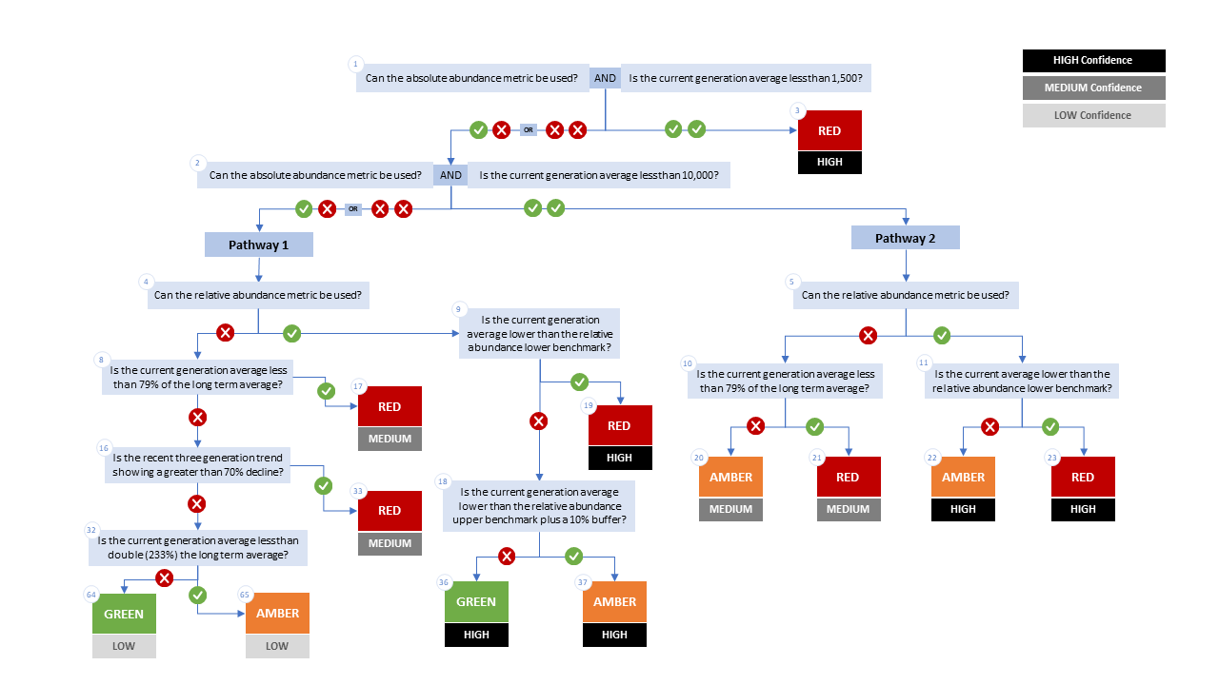

Figure A1. WSP rapid status decision tree (Table 2 includes written descriptions). To assess a CU, metric values are compared to thresholds presented at each decision point. Yes or No answers split each path of the decision tree, terminating at WSP rapid status assignments. The different splits are identified as nodes: 1 to 65. Pathway 1 is taken when the CU has no absolute abundance data, or these data exist, but fall above its upper threshold of 10,000. Pathway 2 is taken when the CU has absolute abundance data and these fall under its upper benchmark of 10,000.

Appendix B: Meeting History and Participants
Tables and summaries of meetings and participants, specifically participants who identified as a subject matter expert for one or more CUs.
Table B1. Participants for the expert review of Interior Fraser Coho held February 28, 2025 9:00am-12:00pm PST
Attendee | Affiliation
Chuck Parken | DFO
Colin Bailey | DFO
Sara Martin | DFO
Morgan Dunne | DFO
Julie Hewlett | DFO
Nicole Trouton | DFO
Amber Messmer | DFO
Sue Grant | DFO
Bronwyn MacDonald | DFO
Isabella Borea | DFO
Marissa Glavas | DFO
Elinor McGrath | Okanagan Nation Alliance
Peter Nicklin | Tŝilhqot’in National Government
Kelsey Campbell | A’Tlegay Fisheries
Michelle Walsh | Shuswap Nation
Randy Billyboy | Tŝilhqot’in National Government

Consensus: general agreement of group as a whole, or absence of evidence-based opposition to conclusions. Determined by the “weight of evidence” (scientific data, information, and analysis ) where multiple results are reported. In the event of disagreements, equally plausible conclusions can be reported. Dissenting views must be clearly described in the narrative.

